
www.dezyneecole.com

Title of Project
One Frustration, Fixed
Project Report
Submitted By
Pooja Khandelwal & Meenakshi Mali
Department – BCA
Semester – 3rd
Session – 2025–26

Project Report of
Identity 2026

Submitted to
Dezyne École College
Towards the Partial Fulfilment of
BCA 2nd Year

By
Meenakshi Mali & Pooja Khandelwal


www.dezyneecole.com
2025-2026

Acknowledgement

We take this opportunity to express our sincere gratitude to Dezyne École College for providing us with the knowledge, resources, and guidance essential to the successful completion of this project.
Our deepest thanks to our respected Principal, Dr. Vinita Mathur, for her visionary leadership and continuous encouragement. Her commitment to academic excellence and student growth has been a constant source of motivation and pride.
We are equally thankful to all our faculty members for their consistent support, expert advice, and valuable insights that shaped our learning and helped us achieve this milestone.
Lastly, we extend heartfelt thanks to everyone who directly or indirectly contributed to the success of this project.
We are proud to be part of Dezyne École College, an institution that truly nurtures professionalism, innovation, and purpose.

With sincere appreciation,
Meenakshi Mali & Pooja Khandelwal
Department of BCA
Dezyne École College, Ajmer

Declaration of AI Tool Usage
AI tool | What I asked it to do | What I wrote, changed or checked myself
ChatGPT | Explain Java, Spring Boot, REST APIs, and database integration concepts. | Reviewed the explanations and applied the relevant concepts to my project.
ChatGPT | Help understand errors and suggest possible solutions. | Applied suggested changes and checked whether the errors were resolved.
ChatGPT | Help identify and understand programming errors. | Applied relevant corrections and checked whether the errors were resolved.
ChatGPT | Explain how JavaScript Fetch API works. | Reviewed the explanation and checked how API requests were handled in my code.
ChatGPT | Explain JUnit testing concepts and test results. | Reviewed the test output and checked the reported results.

Declaration: I/We confirm that this entry is our own work, that every AI tool used is listed above, and that I/we can explain every part of the submitted code.
Project Team Members: Meenakshi Mali and Pooja Khandelwal
College: Dezyne Ecole College, Ajmer
Signature
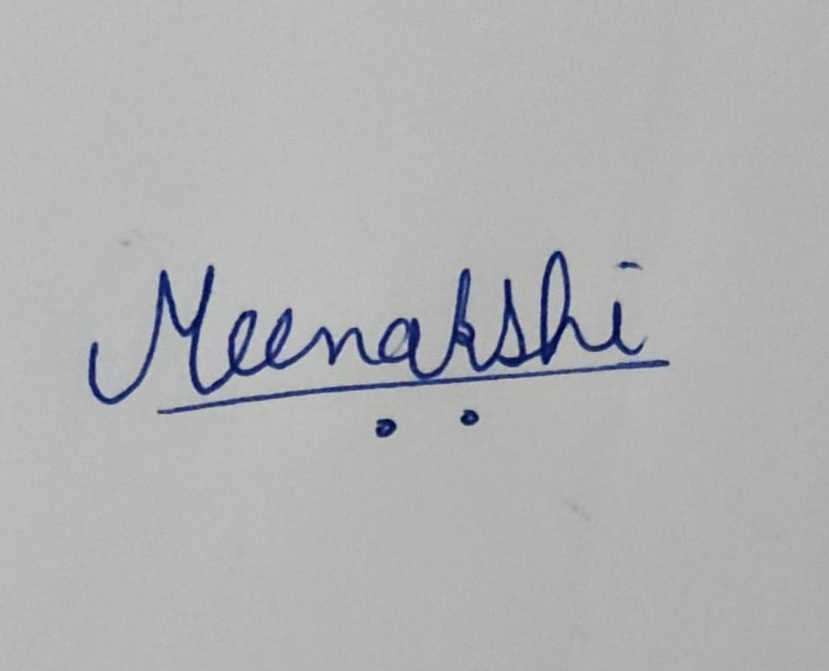: 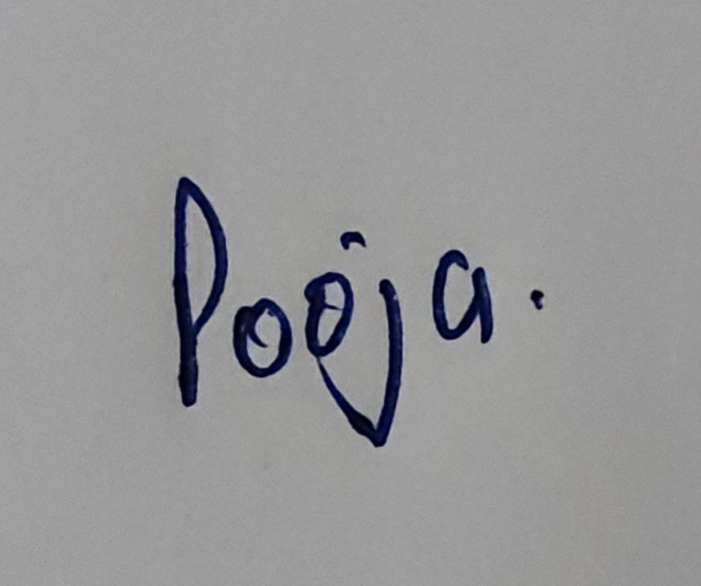
Date :27-10-2026

